Script-Controlled ACL – Restrict Record Access Based on Field Value
Project Report
Table of Contents

1. INTRODUCTION

1.1 Project Overview
This project implements record-level security on a ServiceNow custom table using script-controlled Access Control Lists (ACLs). A custom table, Institution Details (u_institution_details), stores student records carrying a Branch value of ECE, EEE or CSE. Four ACLs — read, create, write and delete — are built on that table and gated by four custom roles (bb1, bb2, bb3, bb4). The read ACL combines a data condition (Branch is EEE) with an advanced script, so a user holding bb1 sees only EEE records, a user with no role sees nothing, and an administrator sees everything.
The build was completed in a personal developer instance within a 3-hour timebox.

1.2 Purpose
The purpose is to demonstrate that access in ServiceNow can be decided by the value of a field on the record and not only by the role on the user. Role-only security is all-or-nothing: a user either sees a table or does not. Many real systems need a narrower rule — a department head should see their own department’s records and no one else’s.
This project proves out that pattern and shows how each CRUD operation can be released separately, so read, create, write and delete privileges can be granted in stages rather than as one block.

2. IDEATION PHASE

2.1 Problem Statement
An institution keeps all student records in one table. Faculty from every branch need access to that table, but a faculty member of one branch must not read, edit or delete the records of another branch. Granting a single table-level role exposes every row; creating one table per branch duplicates schema and reporting.
Problem statement: a branch user needs to work with records of their own branch only, from the same shared table, without seeing the rest — and the administrator must still retain full visibility.

2.2 Empathy Map Canvas
User under study: a faculty member of the EEE branch working on the Institution Details table.
Quadrant | Observations
Says | “I only handle EEE students.” “Why am I seeing CSE records I cannot touch?”
Thinks | Worries about opening the wrong record; unsure which rows are actually hers to edit.
Does | Opens the Institution Details list, filters by branch manually, updates her students’ details.
Feels | Anxious about accidental edits to other branches; frustrated by a cluttered list.
Pain | Manual filtering every time; no guarantee the data she sees is the data she owns.
Gain | A list that already contains only her branch, with edit and delete available where permitted.

2.3 Brainstorming
Four approaches were put forward and assessed.
Idea | How it works | Verdict
Separate table per branch | One table each for ECE, EEE, CSE | Rejected — triples schema and breaks shared reporting
Client-side filter / saved query | Default list filter set to the user’s branch | Rejected — cosmetic only; the data is still reachable by URL
Role-only ACL | One role grants access to the whole table | Rejected — no row-level distinction
Script-controlled ACL with data condition | Condition on Branch plus an advanced script evaluating the user’s role | Selected — enforces at the server, works on list, form and Service Portal
The selected idea was extended: instead of one ACL, four separate ACLs (read, create, write, delete) each backed by its own role, so privileges are layered one at a time and each can be tested in isolation.

3. REQUIREMENT ANALYSIS

3.1 Customer Journey Map
Stage | What the user does | What the system does | Outcome
Entry | Logs in and opens the Institution Details list | Evaluates the read ACL for every row | Only permitted rows are sent
Browse | Scans the list of students | Applies the Branch is EEE condition plus the script | EEE rows only; others never appear
Create | Clicks New | Evaluates the create ACL (bb2) | New button appears only with bb2
Edit | Opens a record and changes a field | Evaluates the write ACL (bb3) | Fields are editable only with bb3
Delete | Selects a row and chooses Delete | Evaluates the delete ACL (bb4) | Delete action offered only with bb4
Admin review | Administrator opens the same list | Admin overrides the ACL | All branches visible

3.2 Solution Requirement
Functional requirements
ID | Requirement
FR-1 | A custom table stores student records with a Branch value of ECE, EEE or CSE
FR-2 | Four custom roles (bb1, bb2, bb3, bb4) gate read, create, write and delete separately
FR-3 | A user holding bb1 reads only records where Branch is EEE
FR-4 | A user holding no role reads no records from the table
FR-5 | An administrator reads, creates, edits and deletes all records regardless of branch
FR-6 | The read ACL uses a data condition together with an advanced script
Non-functional requirements
ID | Requirement
NFR-1 | Enforcement is server-side, so it holds on list, form, Service Portal and direct URL access
NFR-2 | The security_admin role must be elevated before an ACL can be created or modified
NFR-3 | The script returns a boolean on every path, with no null or undefined result
NFR-4 | All work is captured in a single update set so it can be moved between instances

3.3 Data Flow Diagram
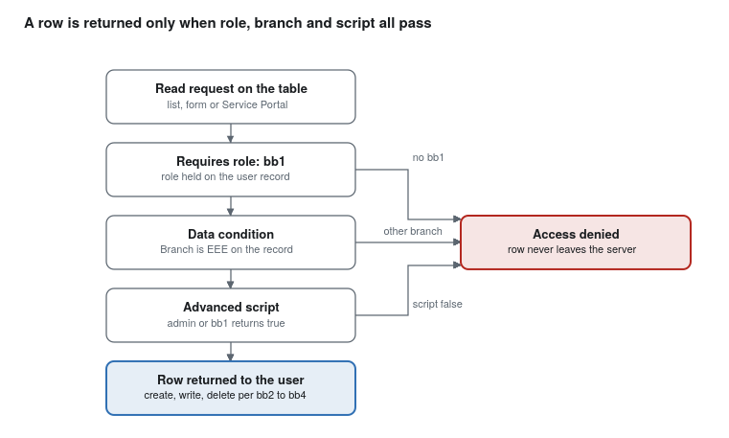
ACL evaluation flow — three gates, two outcomes
The request is evaluated top down. The role check runs first, the data condition narrows the rows to the EEE branch, and the advanced script makes the final decision. A failure at any gate removes the row before it ever reaches the browser.

3.4 Technology Stack
Layer | Component used
Platform | ServiceNow personal developer instance, Global application scope
Data | Custom table Institution Details (u_institution_details)
Security | Access Control (ACL) records, custom roles bb1 to bb4, security_admin elevation
Logic | Server-side JavaScript in the ACL advanced script, GlideSystem (gs.hasRole)
Interface | ServiceNow list view, form view and Service Portal
Testing | Impersonation of the test user EEE User and of the administrator

4. PROJECT DESIGN

4.1 Problem Solution Fit
Element | Fit
Customer segment | Faculty and staff who own records of one branch inside a shared institutional table
Problem | They can see and change records belonging to other branches
Triggers | A shared table, a mixed list, and no row-level rule
Available alternatives | Manual list filters, separate tables per branch, role-only access
Our solution | A script-controlled ACL that tests the record’s Branch value against the user’s role
Channels of behaviour | List view, form view, Service Portal and direct URL — all covered, because the check is server-side

4.2 Proposed Solution
One custom table holds every student record. Four ACLs are created on that table, one per operation, each requiring its own role:
Operation | ACL type | Required role | Data condition | Advanced script
read | record | bb1 | Branch is EEE | Yes — admin or bb1 returns true
create | record | bb2 | none | No
write | record | bb3 | none | No
delete | record | bb4 | none | No
The read ACL carries the branch logic because read is the operation that decides what a user can see at all. The remaining three are role-only, so once a user can see EEE rows, each further privilege is released by granting one more role. Admin overrides is left ticked on every ACL, so the administrator keeps full access without a separate rule.
The script used on the read ACL:
(function () {
// Allow admin users full access
if (gs.hasRole('admin')) {
return true;
}
// Allow only EEE branch users to see EEE records
if (gs.hasRole('bb1')) {
return true;
}
// Deny access for all others
return false;
})();

4.3 Solution Architecture
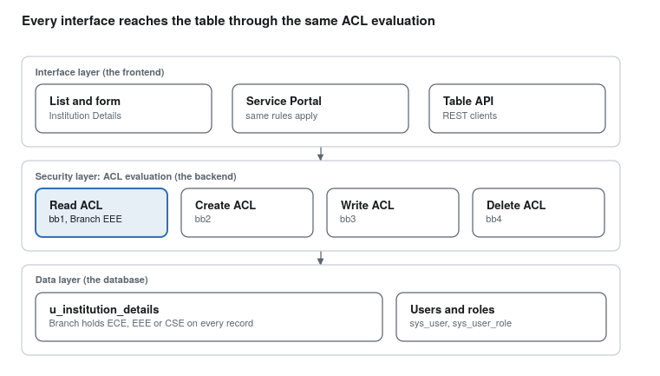
Solution architecture — three layers, four ACLs
Every interface in the access layer reaches the table through the same ACL evaluation, so a user cannot bypass the rule by changing the view or pasting a record URL. The identity tables supply the roles the ACLs test.

5. PROJECT PLANNING & SCHEDULING

5.1 Project Planning
The build was planned as five milestones inside a 3-hour timebox, each ending in something testable.
Milestone | Tasks | Duration | Status
M1 — Users and roles | Create the test user EEE User; create roles bb1, bb2, bb3, bb4; assign them to the user | 30 min | Done
M2 — Table and data | Create u_institution_details with Student Roll Number, Student Name, Faculty Name, Branch, Email, Phone Number, Description; add six sample records across ECE, EEE and CSE | 45 min | Done
M3 — Read ACL | Elevate security_admin; create the read ACL with role bb1, data condition Branch is EEE and the advanced script | 45 min | Done
M4 — Remaining ACLs | Create the create (bb2), write (bb3) and delete (bb4) ACLs | 30 min | Done
M5 — Testing | Impersonate the test user at each role level, then the administrator, and record the results | 30 min | Done
The roles were granted one at a time during M5 rather than all at once, so each ACL could be seen taking effect on its own.

6. FUNCTIONAL AND PERFORMANCE TESTING
Testing was done by impersonation from an administrator session, granting the roles one at a time.
# | Test case | Roles held | Expected result | Actual result
T1 | Open the Institution Details list | none | No records visible | Pass — “No records to display”
T2 | Open the list | bb1 | Only EEE records visible | Pass — 2 EEE rows of 6
T3 | Reach the table by URL (u_institution_details.list) | bb1 | Still only EEE records | Pass — the filter cannot be bypassed
T4 | Look for the New button | bb1 | Not available | Pass
T5 | Look for the New button | bb1, bb2 | Available | Pass
T6 | Edit the Description field inline | bb1, bb2 | Not editable | Pass
T7 | Edit the Description field inline | bb1, bb2, bb3 | Editable and saved | Pass — value “ACL is Executed” saved
T8 | Delete a record from the list | bb1, bb2, bb3 | Delete action absent | Pass
T9 | Delete a record from the list | bb1, bb2, bb3, bb4 | Delete allowed with confirmation | Pass
T10 | Open the list as administrator | admin | All six records across all branches | Pass

6.1 Performance Testing
No load or stress testing was carried out, and no response times were measured — the instance held only six records, so any timing taken here would not be meaningful. The observations below are qualitative.
Aspect | Observation
List rendering | No visible delay between an unrestricted and a restricted list at this record count
Script cost | The advanced script runs per record per operation; it only calls gs.hasRole, with no GlideRecord query inside it
Scaling risk | Not measured. A script-controlled read ACL is evaluated per row, so cost grows with the number of rows returned; a query with a database lookup inside the script would be the point of concern on a large table
Caching | gs.hasRole reads from the session’s role set rather than querying the role tables each time
A load test against a table of realistic size would be needed before this pattern is taken to production.

7. RESULTS

7.1 Output Screenshots
The captured screens and what each one proves. Paste each image under its caption — the images themselves are in the original lab document and have not been carried into this report.
# | Screen | What it shows
S1 | User record — EEE User | Test user created with User ID EEEUser and email eeeuser@gmail.com
S2 | Role record — BB1 | Custom role created; bb2, bb3 and bb4 follow the same form
S3 | Table record — Institution Details | Table u_institution_details created, not extending any table
S4 | Table Columns list | All seven fields with their types, including Branch as a choice field
S5 | Institution Details list as administrator | Six records across ECE, EEE and CSE
S6 | Elevate role dialog | security_admin elevated before any ACL work
S7 | Read ACL form | Type record, operation read, Advanced ticked, data condition Branch is EEE, script in place
S8 | List impersonated as the test user with bb1 | Two EEE records only
S9 | List impersonated with no role | “No records to display”
S10 | List with bb1 and bb2 | EEE records plus the New button
S11 | Inline edit with bb1, bb2 and bb3 | Description accepts “ACL is Executed”
S12 | Delete confirmation with all four roles | Delete offered on the selected EEE record
S13 | List as administrator | All six records regardless of branch
Result: all ten functional test cases passed. Branch-based read restriction, staged create, write and delete privileges, and full administrator override all behaved as designed.

8. ADVANTAGES & DISADVANTAGES
Advantages
- Enforcement sits on the server, so it holds across list, form, Service Portal, direct URL and any API that honours ACLs.
- One shared table serves every branch; no duplicated schema and no split reporting.
- Each operation is gated separately, so read, create, write and delete can be granted in stages to the same user.
- The decision is auditable: the data condition and the script both sit on the ACL record and can be read without opening code.
- Admin overrides keeps the administrator working normally without a second rule.
Disadvantages
- The branch value is hard-coded in the design. A new branch, or a user who should see two branches, means another ACL or a rewrite of the script.
- A script-controlled read ACL is evaluated for every row returned, so a heavy script on a large table costs query time.
- Four roles for one table adds administrative overhead; role assignment itself becomes a thing to maintain.
- The script duplicates logic that the data condition already carries, which is useful for teaching but redundant in production — the condition alone would do the branch filtering.
- ACL work requires the elevated security_admin role, so routine changes need an elevation step and are easy to forget.

9. CONCLUSION
The project shows that a record’s own field value can decide who may act on it. A user holding bb1 sees only EEE records from a table that also holds ECE and CSE rows; a user with no role sees nothing; the administrator sees everything. Create, write and delete were then released one role at a time on top of that read access, and each step behaved as expected.
The working parts are small: one table, four roles, four ACL records and nine lines of server-side script. What makes it hold is where the check runs — inside the platform, before any row is sent — rather than in the view the user happens to be looking at.

10. FUTURE SCOPE
- Replace the hard-coded branch with a lookup, so the ACL compares the record’s Branch against a Branch field on the user record. One rule would then serve every branch.
- Move the branch membership to groups and test with gs.getUser().isMemberOf(), which scales better than one role per branch.
- Add field-level ACLs so sensitive columns such as Email and Phone Number can be hidden even on rows the user may read.
- Extend the pattern to a Service Portal widget and confirm the same rules apply there.
- Add a Business Rule or Flow to log denied access attempts for audit.
- Package the whole build into an update set or a scoped application so it can be promoted between instances.
- Benchmark the read ACL against a table of 100,000 or more rows before any production use.

11. APPENDIX
Source Code — read ACL advanced script
(function () {
// Allow admin users full access
if (gs.hasRole('admin')) {
return true;
}
// Allow only EEE branch users to see EEE records
if (gs.hasRole('bb1')) {
return true;
}
// Deny access for all others
return false;
})();
Table definition — u_institution_details
Field label | Type | Reference / choices
Student Roll Number | String (auto number) | prefix INS, e.g. INS0001001
Student Name | Reference | User (sys_user)
Faculty Name | Reference | User (sys_user)
Branch | Choice | ECE, EEE, CSE
Email | String | —
Phone Number | String | —
Description | Multi-line string | —
ACL summary
ACL | Operation | Role | Advanced
u_institution_details | read | bb1 | Yes, with condition Branch is EEE
u_institution_details | create | bb2 | No
u_institution_details | write | bb3 | No
u_institution_details | delete | bb4 | No
Dataset Link
Six sample records created by hand in the instance — two ECE, two EEE, two CSE. No external dataset was used.
GitHub & Project Demo Link
- GitHub repository: to be added
- Project demo video: to be added
- Instance URL: to be added

